**2016 Solutions (Higher Level)**

**2016 Question 1**

1. **Explain how the centre of gravity was found**

Balance (horizontally) on a pivot // suspend (horizontally) from a thread

1. **Explain how the weight of the metre stick was found**

Newton balance / weighing scales // mass balance & multiply by g

1. **Explain how the upward forces and downward forces were determined.**

Upward: newton balances

Downward: known weights

1. **Give one possible reason why the centre of gravity is not at the 50.0 cm mark.**

Stick worn at one side / stick had a hole in one side / stick not of uniform density

1. **Use the data given to calculate the net force acting on the metre stick**

Upward force = 3.9 + 4.1 = 8.0 N

Downward force = 2 + 3 + 2 + 1.1 = 8.1 N

Net vertical force = 0.1 N // upward ≈ downward

1. **Use the data given to calculate the sum of the moments about the 40 cm mark of the metre stick.**

Moment = force × displacement

Clockwise moments = (2 × 0.52) + (1.1 × 0.102) + (3.9 × 0.04) = 1.3082 N m

Anti-clockwise moments = (2 × 0.24) + (4.1 × 0.20) = 1.3 N m

Sum of moments ≈ 0 N m // clockwise ≈ anti-clockwise

1. **Explain how your calculations verify the laws of equilibrium.**

Net vertical force ≈ 0 N

Sum of moments about a point ≈ 0 N m

**2016 Question 2**

1. **Draw a labelled diagram of the arrangement of the apparatus used in this experiment.**

**Indicate on your diagram the measured length of the string.**

Stretched string, two bridges, tuning fork / signal generator,Newton balance / pulley & (known) weight

Length shown between two bridges

1. **Draw a suitable graph to illustrate the relationship between *f* and *l*.**

Values of ¹/f or ¹/l

Axes labelled

Points plotted

Straight line with good fit

1. **State the relationship and explain how the graph verifies it.**

f ∝ ¹/l

Straight line through origin

1. **Use your graph to calculate the length of the string at a frequency of 192 Hz**

Value read from graph $1/l$ ≈ 1.52 m–1

*l* ≈ 0.66 m

1. **Use your graph to calculate the mass per unit length of the string.**

General formula: 

Compare to y = m x



So plotting *f* on the y axis and $1/l$ on the x axis means that the slope corresponds to 

We were told in the question that the tension was 8.5 N.

Slope = 

*μ* ≈ 1.3 × 10–4 kg m–1

**2016 Question 3**

1. **Describe, with the aid of a labelled diagram, how the data were obtained.**

|  |  |
| --- | --- |
| Laser  Grating & screen  correct arrangements  Measure D from grating to screen  Measure x from central image to other images tanθ = x/D | Vapour lamp  Grating & spectrometer  correct arrangements  measure angle on left, θL  measure angle on right, θR  ½(θL ± θR) |

1. **Use the data to calculate the wavelength of the light**

d = 2 × 10–6 m

nλ = dsinθ

λ = 5.9 × 10–7 m

Repeat and average appropriately

1. **Use the data to calculate the maximum number of images that could be observed.**

θmax = 90°

nmax = 3

maximum number of images = 3 + 3 + 1 (the central image) = 7

1. **Explain what would happen to the positions of the images if the wavelength of the light was decreased**

They would be closer together

1. **Explain what would happen to the positions of the images if the diffraction grating was replaced with a diffraction grating of 300 lines per mm.**

They would be closer together

**2016 Question 4**

1. **Describe how the data were collected.**

Resistance: ohmmeter/multimeter

Length: metre stick

Diameter: micrometer

1. **How did the student ensure that the wire was of uniform diameter?**

Measure diameter/thickness at different positions // no kinks

1. **Use the data to calculate the resistivity of nichrome.**

A = πr2

r = ½d

ρ = RA/l

ρ = 1.06 × 10–6 Ω m

1. **Draw a labelled diagram of the arrangement of the apparatus used in this experiment.**

Thermometer and source of heat

Wire in container of liquid

Ohmmeter/multimeter connected across the wire

1. **Draw a sketch of the graph.**

Labelled axes

Straight line with positive slope and correct intercept

1. **Describe this relationship.**

Linear relationship

**2016 Question 5**

1. **A cyclist’s average power output when climbing a mountain is 280 W.**

**He completes the climb in 18 minutes. How much energy does he use?**

$$Power= \frac{Energy}{time}$$

E = (P)(t) = (280)(18)(60)

E = 302400 J

1. 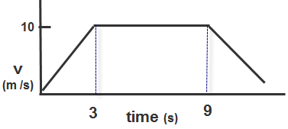**A sprinter starts from rest and accelerates uniformly for 3 secs until she reaches a velocity of 10 m s–1.   
   She then runs at a constant velocity for 6 seconds before decelerating.**

**Sketch a velocity-time graph of her motion.**See graph

1. 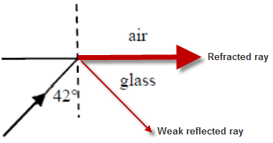**In your answer book copy the diagram on the right, which shows a light ray incident on the interface between glass and air.**

**In your diagram, sketch (*i*) the refracted ray, (*ii*) the weak reflected ray.**

**The critical angle of the glass is 42°.**

See diagram

1. **What is meant by the polarisation of a wave?**

One plane of wave vibration



1. **The ear canal acts as a cylindrical pipe closed at one end.   
   It is of average length 2.3 cm. The speed of sound in air is 340 m s–1.**

**What is the fundamental frequency of the ear canal?**

c = fλ $f=\frac{c}{λ}$ λ = 4*l* = (4)(.023)= 0.092 m

$f=\frac{c}{0.092}$ = 3696 Hz

1. **State and define the SI unit of capacitance.**

The farad. One farad is equivalent to one Couloumb per volt

1. **Why is it more economical to transmit electrical energy at high-voltage?**

Low current so less heat lost

1. **When does the photoelectric effect occur?**

When a photon/light/em radiation strikes a surface with a suitable frequency/energy

1. **The magnets in the Large Hadron Collider (LHC) operate at a temperature of 1.92 K, which is colder than deep space.**

**What is the value of this temperature in degrees Celsius (°C)?**

**°C** = temp in kelvin - 273.15

1.92 - 273.15 = – 271.23 °C

Note that you would have lost 1 mark here if you used 273 instead of 273.15

1. **Experiments in the LHC in 2016 have suggested the existence of pentaquarks, hadrons that consist of five quarks.   
   What terms are used for hadrons that consist of (i) two quarks, (ii) three quarks?**
2. Mesons (ii) Baryons

**2016 Question 6**

1. **Explain the underlined term.**

An object exhibits simple harmonic motion if its acceleration is proportional to its displacement and is opposite in direction.

1. **State Hooke’s law.**

For a spring which undergoes extension or compression, the restoring force is proportional to the displacement, and opposite in direction.

1. **Use Hooke’s law to show that the mass executes simple harmonic motion.**

F = ‒ks

ma = ‒ks

$a=-\frac{k}{m}$ s

This is consistent with simple harmonic motion

1. **Calculate the length of the pendulum**

$T^{2}=\frac{4π^{2}l}{g}$

$l=\frac{gT^{2}}{4π^{2}}$

$l=\frac{(9.8)2^{2}}{4π^{2}}$

*l* = 0.99 m

1. **Calculate the maximum angular displacement of the pendulum.**

“Calculate the maximum angular displacement” means “calculate the largest angle that the pendulum will be from the equilibrium”.

Equilibrium position is where the pendulum would be when it stops - in this case the pendulum would come to rest at the bottom of its cycle. So *maximum* angular displacement is the angle between this point and the *top* of the pendulum’s cycle.

We are told that the pendulum travels a distance of 18 cm during each oscillation. One oscillation corresponds to one full cycle – all the way over and all the way back. The arc length between equilibrium position and the top of the pendulum’s cycle therefore corresponds to *one quarter* of the full cycle

$θ= \frac{arc length}{radius}$

arc length = (¼)(0.18) = 0.045 m

and the radius corresponds to the length of the pendulum: 0.99 m

$$θ= \frac{0.045}{0.99}$$

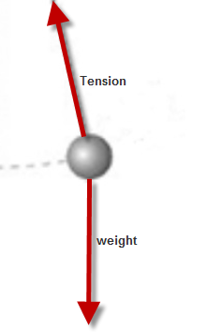= 0.045 radians

1. **Draw a diagram to show the forces acting on the bob when it is at its maximum displacement.**

Weight down

Tension up at angle to the vertical

1. 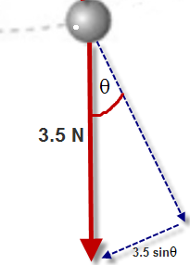**Calculate the restoring force at this point.**

The restoring force is the force acting in towards equilibrium position.

There doesn’t seem to be any force acting in this direction, but there is a component of the weight acting inwards.   
To find out the size of this inward component we resolve the 3.5 N into 2 components; one acting in the direction we’re interested in and the other at right angles.

From the diagram we can see that the component acting inward corresponds to 3.5 sinθ

F = 3.5 sin 0.045 {remember to set your calculator to ‘radians’ mode, because our answer for θ was in radians}

F = 0.16 N

1. **At what point during its movement does the bob have its greatest angular velocity?**

When θ = 0 / at the centre of oscillation / at its lowest point

1. **At what height will the period of a simple pendulum be 2% more than the period of a simple pendulum of the same length at the Earth’s surface?**

*Where do I even begin with this bast@rd of a question.*

$T=2π\sqrt{\frac{l}{g}}$ $T^{2}=4π^{2}\frac{l}{g}$ $g=4π^{2}\frac{l}{T^{2}}$ $g∝\frac{1}{T^{2}}$

Now from our chapter on *Gravity* we had the following relationship: $g=\frac{Gm}{d^{2}}$ $g∝\frac{1}{d^{2}}$

So if $g∝\frac{1}{T^{2}}$ and $g∝\frac{1}{d^{2}}$ then {*and* *I’m not saying this is obvious, or that anything like it was on any past paper or even on the syllabus}* mathematically we can say that *T* ∝ *d*

So if we want *T* to increase by 2% more than it would be on the surface of the Earth, then we need *d* to increase by 2%.

(*d* represents the radius of the Earth *=* 6371 km)

2% of 6371000 = 127.4 km

So new height = radius of the Earth + 127.4 km (i.e. 127.4 km above the surface of the Earth).

**2016 Question 7**

1. **Distinguish between heat and temperature.**

Heat is a measure of energy

Temperature is a measure of hotness

1. **State the principle of conservation of energy.**

Energy cannot be created or destroyed, it can be changed from one form into another

1. **Calculate the height of the Niagara Falls.**The key phrase here is “due to gravitational potential energy being converted into heat energy.**”**

Mathematically mgh = mcΔθ

$$h= \frac{(c)(Δθ) }{g}$$

$$h= \frac{(4200)(0.12) }{9.8}$$

h = 51.4 m

1. **In reality the increase in temperature will be much smaller.**

**Suggest a reason for this.**

Much of the heat energy will be lost to the environment as the water falls

1. **Describe the operation of a heat pump**

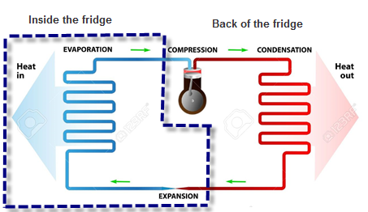

A special liquid is pumped around the pipe as shown.

Inside the dotted section the liquid expands quickly, and in going from a liquid to a gas it takes in energy from around the pipe.

*Outside* the dotted section a pump is used to *compress* the gas which causes it to go back into the liquid state, and in the process it gives heat energy back out to the surroundings.

1. **State two desirable physical properties of the fluid used in a heat pump.**

High (specific) latent heat of vaporisation

Low boiling point

1. **Calculate the mass of fluid that has evaporated.**

$$E = ml$$

E = 12 × ${10}^{3}$ J

*l* = 4.6 $×{10}^{6}$ J kg–1

m = $\frac{12 ×{10}^{3}}{4.6 ×{10}^{6}}=$ 0.0026 kg

1. **Calculate the fall in temperature of the air in the refrigerator.**

Any time there is a change in temperature it means we need to use the formula Q = mcΔθ.

But note that we are now interested in the air in the fridge itself, not the fluid in the pipes of the heat pump.

First we need to work out the mass of the air

ρ = $\frac{m}{V}$

m = (ρ)(V)

m = (1.23 kg m–3)(0.6 m3)

m = 0.74 kg

The heat pump removes 12 kJ of energy from the air in the refrigerator as the fluid evaporates.

So Energy removed = 12000 J.

cair = 1005 J kg–1 K–1

Q = mcΔθ

12000 = (0.74)(1005)(Δθ)

$$Δθ=\frac{12000}{(0.74)(1005)}$$

Δθ = 16.1 °C

**2016 Question 8**

1. **What is a semiconductor?**

Resistivity/conductivity between that of a conductor and an insulator

1. **Distinguish between intrinsic and extrinsic conduction in a semiconductor.**

Intrinsic: pure semiconductor with equal number of electrons & holes

Extrinsic: doped semiconductor with unequal number of electrons & holes

1. **Explain how a pure semiconductor can be converted into (i) a p-type and (ii) an n-type semiconductor.**

p-type: doped with an element with fewer outer electrons / boron

n-type:doped with an element with more outer electrons / phosphorus

1. **Describe, with the aid of a labelled diagram, how a depletion layer is formed at the p-n junction.**

The p-type material is connected to the n-type material.

1. Due to thermal agitation, some free electrons in the n-type material diffuse over to the p-type material, where they combine with nearby positive holes, with the result that the region is depleted of two of its charge carriers.
2. Similarly on the p-type side some positive holes diffuse over to the n-type material, where they too combine with nearby electrons, with the result that the region gets depleted of two more of its charge carriers.
3. The end result is that a depletion region is formed at the junction of the p-type and n-type materials, where there are no free charge carriers. This region therefore acts as an insulator.
4. **What is a depletion layer?**

It is a region with no charge carriers / high resistance

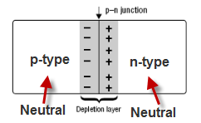

1. **Indicate on your diagram the sections of the p-n junction that are positively charged, negatively charged and neutral.**

See diagram

1. **Explain how a diode might be protected from having too large a current flowing through it when it is connected across a battery, as in the diagram.**

Resistor in series

1. **What would be the effect on the current flowing in this diode if the terminals of the battery were reversed? Explain your answer.**

There would be a very small (or zero) current.

The diode is now in reverse bias so there is a very large resistance/depletion layer

1. **A diode can be used as a rectifier. What is the function of a rectifier?**It converts a.c. to d.c.
2. **What property of a diode makes it useful in a rectifier circuit?**

Allows current to flow in one direction only

**2016 Question 9**

1. **Explain the underlined terms.**

Fission: the breaking up of a large nucleus into smaller nuclei with the release of energy and neutrons

*(–1 for “atom” instead of “nucleus”)(–1 for omission of nuclear size) (–1 for omission of neutrons)*

Radioactivity: the disintegration of a nucleus with the emission of one or more types of radiation.

*(–1 for “atom” instead of “nucleus”)*

1. **Calculate the energy released during this reaction.**

Mass before = mass of uranium nucleus + mass of neutron

= 3.9529 × 10–25 + 1.674 927 28 × 10–27

Mass before = 3.9696 × 10–25 kg

Mass after = mass of barium nucleus + mass of krypton nucleus + mass of 3 neutrons

= 2.3066 × 10–25 kg + 1.6099 × 10–25 kg + 3(1.674 927 28 × 10–27)

Mass after = 3.9667 × 10–25 kg

Loss in mass = total mass beforehand – total mass afterwards

= (3.9696 × 10–25) – (3.9667 × 10–25)

= 2.9 × 10–28 kg

E = mc2

Energy released = (2.9 × 10–28)(2.998 × 108)2

E = 2.6 × 10–11 J

1. **How many of the neutrons emitted in a fission reaction must, on average, cause a further fission so that the reaction is self-sustaining and safe?   
   Explain your answer.**

1

More than one would result in an uncontrolled reaction while less than one would result in the chain-reaction ending too quickly.

1. **Explain the function of the moderator.**

Slows down neutrons

1. **Write a nuclear equation for the decay of radium–225.**
$${}_{88}^{225}{Ra→}{}_{89}^{225 }{Ac+ {}_{-1}^{0}e}$$

2. **Calculate the number of radium–225 nuclei in a sample that has an activity of 5600 Bq.**

T1/2 =

λ = $\frac{ln 2}{T_{1/2}}$ = $\frac{0.693}{14.9×25×60×60}$

λ = 5.38 × 10–7 s–1

Activity = λN

N= $\frac{A}{λ}$ = $\frac{5600}{5.38 × {10}^{–7}}$

N = 1.04 × 1010

**2016 Question 10**

1. **State Faraday’s law of electromagnetic induction.**

Emf induced is proportional to the rate of change of magnetic flux

Or correct equation and notation

1. **Describe an experiment to demonstrate this law.**

Move the magnet in and out of the coil slowly and note a slight deflection in the galvanometer.

Move the magnet quickly and note a greater deflection.

1. **Derive an expression for the effective resistance of two resistors in parallel.**

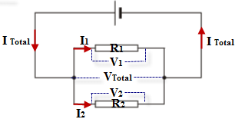For currents in parallel: ITotal = I1 + I2

But I = (Ohm’s Law)

⇒ $\frac{V}{R_{T}}$ = $\frac{V}{R_{1}}$ + $\frac{V}{R_{2}}$

We can now cancel the *V*’s because the voltage is the same for resistors in parallel

⇒ $\frac{1}{R_{T}}$ = $\frac{1}{R_{1}}$ + $\frac{1}{R_{2}}$

1. 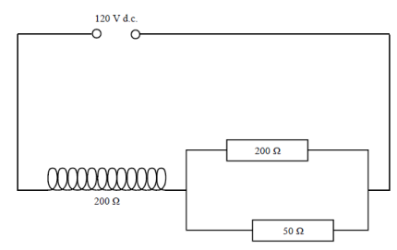**Calculate the current in the coil**

RT for resistors in parallel:

= +

=

RT for resistors in parallel = 40 Ω

Rcircuit = 40 + 200 = 240 Ω

V = IR

$I=\frac{V}{R}$ = $\frac{120}{240}$ = 0.5 A

1. **Calculate the current in the 50 Ω resistor.**

Voltage across 200 ohm resistor = IR = (0.5)(200) = 100 V

So voltage across parallel resistors must be (220 – 200) = 20 V

To calculate the current in the 50 Ω resistor; R = 50 Ω, V = 20 V, I = $\frac{V}{R}$ = $\frac{20}{50}$ = 0.4 A

Alternative approach:

I50 = (ITotal) = 0.4 A

1. **Calculate the average emf induced in the coil during the 3 ms time period**

*E = dΦ/dt*

Induced emf = - $\left(N\right)[\frac{final flux – initial flux}{time taken}]$

Induced emf = - $\left(150\right)[\frac{{4.5 ×10}^{-4}- 0}{{3×10}^{-3}}]$

*E* = 22.5 V

1. **Calculate the average current in the coil during this period.**

The effective voltage across the coil now corresponds to the initial voltage – the induced voltage.

Ecoil = 120 V - 22.5 V = 97.5 V

$$I_{Total}=\frac{V_{Total}}{R_{Total}}$$

I = $\frac{97.5}{240}$ = 0.406 A

Note that the symbols *V* and *E* are interchangeable here.

**2016 Question 11**

1. **State the laws of refraction.**

Incident ray, refracted ray and normal in the same plane

*n = $\frac{\sin{i}}{\sin{r}}$*

1. **Draw a ray diagram to show the formation of a virtual image in a magnifying glass.**

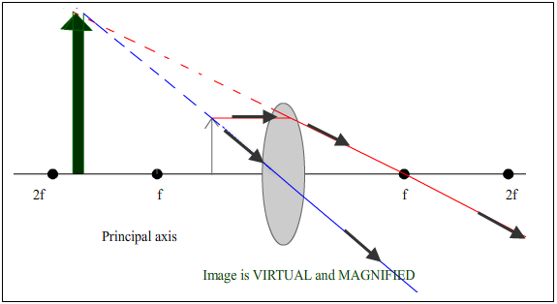See diagram

1. **Explain what is meant by the term wavelength.**

It is the distance between two consecutive crests (or troughs).

1. **List the colours observed by Newton, in order, starting with the colour that was refracted the least.**

Red, orange, yellow, green, blue, indigo, violet

1. **How might he have produced these sources?**

Double slits

1. **Calculate the energy of a photon of green light, which has a wavelength of 510 nm.**

E = hf

h = Planck’s constant; 6.6 × 10-34 J s

f represents frequency. We don’t have a value for frequency but we can work it out using c = fλ.

$f= \frac{c}{λ}$

$$E=h\frac{c}{λ}$$

$$E={6.6 × 10}^{-34}\frac{{3× 10}^{8}}{{510× 10}^{-9}}$$

E = 3.89 × 10–19 J

1. **Describe how these spectra are produced.**

Electrons absorb energy (from electromagnetic radiation) to move to a higher energy level

The electrons then fall back to a lower energy level and the energy gets re-emitted as lower energy electromagnetic radiation (light of a specific colour).

1. **State two differences between photons and electrons.**

Photons have no mass, electrons do.

Photons have no charge, electrons do.

Photons are electromagnetic radiation

**2016 Question 12 (a)**

1. **State the principle of conservation of momentum.**The principle of conservation of momentum states that in any collision between two objects, the total momentum before impact equals total momentum after impact, provided no external forces act on the system.
2. **What daughter nucleus is produced during this alpha-decay?**

$${}_{84}^{212}{Po} →{}_{2}^{4}{He+ {}_{?}^{?}X}$$

The total number on top on the left must equal the total number on top on the right.

The same applies for the bottom.

Once you realise that the atomic number of the daughter product is 82 you then go to the periodic table of elements to identify this atom – it this case the element ‘lead’ has an atomic number of 82

$${}_{84}^{212}{Po} →{}_{2}^{4}{He+ {}_{82}^{208}{Pb}}$$

Daughter nucleus is therefore lead–208

1. **The kinetic energy of the emitted alpha-particle is 8.9 MeV. Calculate its velocity.**

1eV =1.6 x 10–19 Joules

8.9 MeV = (8.9 x 106)(1.6 x 10–19) Joules

E = 1.426 × 10–12 J

Ekinetic = ½mv2

1.426 × 10–12 = ½ mv2

Mass of alpha particle = 6.644 6565 $×$ 10–27 kg {page 46 of log tables}

$$v^{2}{=(2)(\frac{{1.426 × 10}^{–12}}{{6.644 6565 ×10}^{–27 }} )}^{}$$

v = 2.07 × 107 m s–1

1. **Calculate the velocity of the daughter nucleus after the decay.**

Momentum before = momentum after = 0 // ratio of masses = 208:4

v = 4.0 × 105 m s–1

**2016 Question 12 (b)**

1. **Define electric field strength.**

*E =* force per unit charge // *F/Q (*notation required)

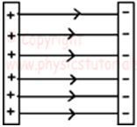

1. **In your answer book, sketch the electric field pattern between two oppositely charged parallel plates.**

Parallel field lines from + to –

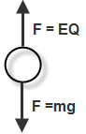

1. **Draw a diagram to show the forces acting on the drop of oil when it is stationary.**   
     
   See diagram
2. **Calculate the charge of the drop.**

Force up = Eq, Force down = mg

Force up = Force down

Eq = mg

E = 3.6 × 104 V m–1

Mass of the drop = 2.4 × 10–15 kg

$$q= \frac{{2.4 × 10}^{-15}(9.8)}{{3.6 × 10}^{4}}$$

q = 6.53 × 10–19 C

1. **How many excess electrons are on this drop?**

An electron has a charge of 1.6 × 10–19 C, so 6.53 × 10–19 C is just approximately equal to the charge of four electrons.

Answer: 4

**2016 Question 12 (c)**

1. **What is meant by the Doppler effect?**

Apparent change in frequency of a wave due to relative motion between source and observer

1. **Define centripetal force.**

Centripetal force is the force acting towards the centre on an object moving in a circle.

1. **Calculate the maximum and minimum frequency of the note detected by an observer**

u = 13 m s–1

f = 1.1 kHz = 1100 Hz

The frequency of the note detected by an observer is a *maximum* as the buzzer moves *away from* the observer, so we use the positive sign below the line.





f'max = 1143.7 Hz

The frequency of the note detected by an observer is a *minimum* as the buzzer moves *towards* the observer, so we use the negative sign below the line.





f'min = 1059.5 Hz

1. **Calculate the maximum and minimum tension in the string.**

m = 70 grams = 0.07 kg

r = 80 cm = 0.8 m

v = 13 m s-1

*{Here we use our basic equation for circular motion:*

$F_{net}= \frac{mv^{2}}{r}$

*Note that there are two forces acting on the mass when it is in both positions; tension and weight (mg)*

*The tension will be different in both cases.*

*At the top, both forces are acting downwards, so we add them together to get $T_{1}+mg= \frac{mv^{2}}{r}$*

*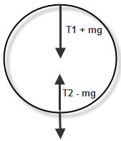At the bottom, tension is acting upwards and weight is acting downwards.   
The tension is the bigger force because this is what is what is responsible for the centripetal motion, so we use T2 – mg =*

*It’s also worth noting that this is another sh1t question, because the speed at the bottom should be much greater than the speed at the top, but here they simply tell you that it is 13 m s-1 in both cases.}*

At the top:

$T_{1}+mg= \frac{mv^{2}}{r}$

$T_{1}= \frac{mv^{2}}{r}-mg$

$T_{1}= \frac{(0.07){13}^{2}}{0.8}-(0.07)(9.8)$

Tmin = 14.1 N

At the bottom:

$$T_{2}-mg= \frac{mv^{2}}{r}$$

$$T_{2}= \frac{mv^{2}}{r}+mg$$

$$T_{2}= \frac{(0.07){13}^{2}}{0.8}+(0.07)(9.8)$$

Tmax = 15.5 N

***{Note that a similar question appeared on the higher level Applied Maths paper in 1995***

***Question 5 (b)}***

A particle of mass *m*, attached to a fixed point by a light inelastic string, describes a circle in a vertical plane.

The tension of the string when the particle is at the highest point of the orbit is T1 and when at the lowest point it is T2.

Prove that T2 = T1 + 6*mg*

Solution

See diagram.

Note that they could have used $F=\frac{mv^{2}}{r}$*or* F = mr $ω^{2}$

In this case they used F = mr $ω^{2}$

Both options would have given the same result.

**2016 Question 12 (d)**

1. **What is a positron?**

Positively charged electron // anti-electron

1. **Why are photons always produced in pairs during pair annihilation?**

To conserve momentum

1. **Write an equation for this annihilation.**
$${}_{-1}^{0}{e+ {}_{+1}^{0}{e →2γ}}$$

2. **Calculate the frequency of the gamma-radiation produced in this annihilation.**

Mass of electron = 9.1093826 × 10-31 kg

Energy ‘released’ when one electron is annihilated = mc2

We only need to look at one electron because two electrons are annihilated to produce two photons, so it’s as if one electron is responsible for producing one photon.

E = (9.1093826 × 10-31)(3 × 108)2

E = 8.198444 × 10-14 J

This energy now goes on to create a photon

Energy associated with a photon = hf

$f= \frac{E}{h}= \frac{{8.198444 × 10}^{-14}}{{6.6260692 × 10 }^{-24}}$

f = 1.237 × 1020 Hz

1. **Compare the energy produced in these two annihilations.**

**Explain your answer.**

Energy from proton annihilation is greater because a proton’s mass is greater

**2016 Question 12 (d)**

1. **Draw a labelled diagram of a d.c. motor.**

Coil; magnet; power supply; carbon brushes; commutator

1. **Use your diagram to explain why the coil of a d.c. motor rotates when current flows through the coil.**

Current carrying conductor in magnetic field

Force on each side

Rotation

1. **Describe how you would demonstrate the principle of operation of an induction motor.**

Apparatus

Method

Observation

1. **State one advantage of an induction motor over a d.c. motor.**

No sparking at brushes // no need to replace brushes